Sorghum App Specification Documentation

Kansas State Extension Platform

Kansas State University | Spring 2020

Table of Contents

**Softwares intended use** **3**

**Discussion on chosen technology** **3**

**Architecture discussion** **3**

**Primary Goals for the Semester** **4**

# Softwares intended use

The sorghum app was created with the intended use to help sorghum farmers and researchers come up with accurate predictions to their sorghum crops’ yield. Currently, the only way of getting crop yield predictions is to take a bunch of sorghum heads from the same plot and count all of the individual pieces of sorghum on each head. This can end up taking quite a long time when most heads will have sorghum counts in the thousands. Preferably, the app will be able to be accurate enough to where it would be unnecessary to do this tedious counting process, which would make yield prediction a much quicker and easier process. The usage of the software is also intended to be simple so it is easily used by those without a technical background. All you need to do is sign into the app, input your field data information, and take a picture of a sorghum head. You will then be given a yield prediction based off of all the information the app was able to collect.

# Discussion on chosen technology

The sorghum app was built with Object-C while using Xcode as the main development tool. This method of development was chosen because, at the time of development, it had the most user support and was the norm when it came to building IOS apps. There is also a large pool of available frameworks which weren’t as extensive at the time as the other main IOS languages, Swift and Ruby. As for the database involved, google firebase was used due to its modularity and functionality. Specifically, it has a lot of built-in tools which make it easy to connect a firebase database to an app which you are developing.

# Architecture discussion Class Diagram

# Database Diagram

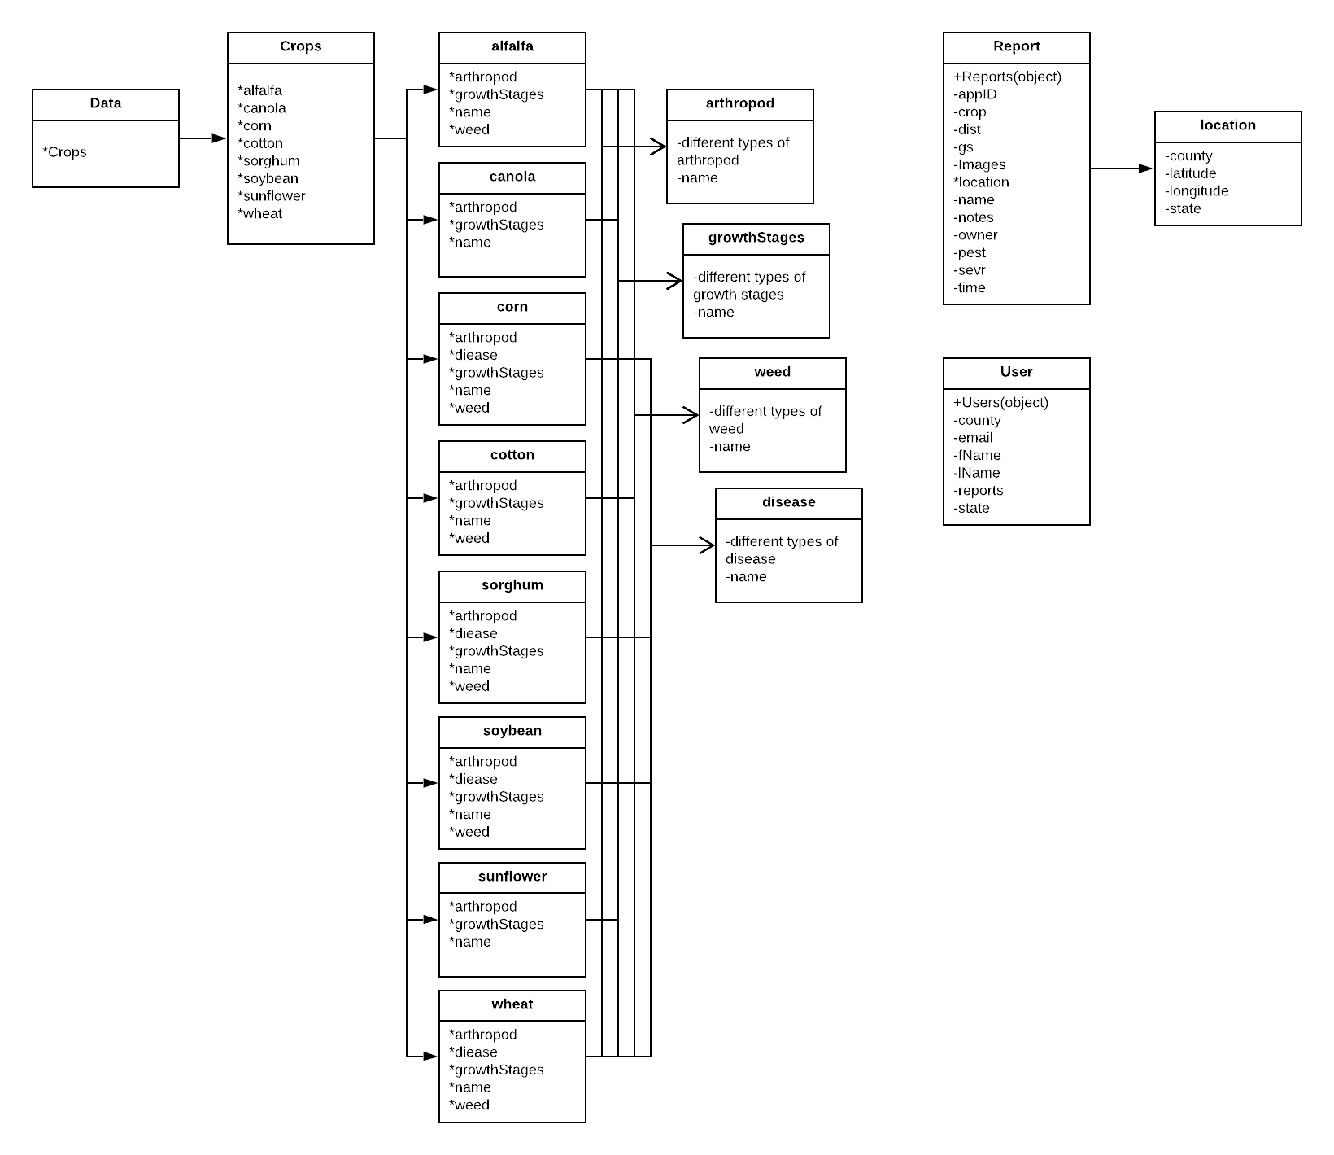

# Primary Goals for the Semester

The plan for this semester is to test the apps calculations against the actual yield calculations taken from the most recent sorghum harvest taken by our client. If the calculations are within an acceptable margin of accuracy, we will give the app back to our clients for them to do their own testing. We will make any changes that they may request, and then we will begin making finalizations to the app. This will include a bit of code clean up and extra commenting. Once the code is cleaned up, we plan to move the app onto the app store.

If the calculations aren’t accurate, we will focus on tweaking the code making those calculations until they are within an acceptable margin of accuracy. We hope that the app will be available for use by next year’s harvest so that it may be used to help speed up sorghum research.